**(CL-1002) Programming Fundamentals Lab** 

**Fall 2021**

**NUCES-FAST Peshawar Campus**

**Assignment # 01**

• The due date for this homework is **November 6th, 2021**

• There is **30%** penalty for late submission.

• Copied assignments will be awarded **zero** marks without any investigation. • All submissions should be made on Google Class Room.

• Upload only a PDF and MS word file including all tasks source code and its output (screen shot).

• You have to copy the source code in your word file. Don't take the screen shot of source code.

• Note that these assignment marks could be graded through a quiz (viva) in class. • Proper Comments your Code otherwise marks will be deducted.

**Question # 01**

Write a function that takes the values of two sides of a right triangle and then determine the size of the hypotenuse. The formula for finding the hypotenuse is



You should ask user to enter the two sides of a rectangle (outside the function and pass its values to function) Function should have **default arguments set to 1, 1**

*Hint: (import math library and use sqrt() built-in function to calculate square root).* **Question # 02**

Write a program that examines three variables—x, y, and z—and

prints the largest odd number among them. If none of them are odd, it should print a message to that effect.

**Note:** You have to take three values from user.

**Sample Output:**

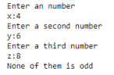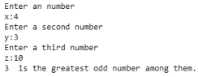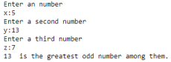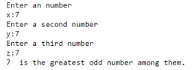

**Question # 03**

Write a program that check whether a year is leap year or not? create a function named isLeap has an formal parameter, year, determines whether the year is a leap year, or not and print the message to that effect. A year is a leap year if it is divisible by 4 but is not divisible by 100 except when divisible by 400.

You should ask user to enter year (outside the function and pass its value to function) Reflect the concept of **required argument**

*Hint :(use conditional statements)*

For example,

• 1999 is not a leap year

• 2000 is a leap year

• 2004 is a leap year

• 1000 is not a leap year

**Sample Output:**





**Question # 04**

Build a GPA calculator that inputs grades of 3 different subjects along with the credit hours

from the user and displays the user’s GPA. The input grades and their corresponding grading points are given below.

Grade Points

**A** 4.0

**A-** 3.67

**B+** 3.33

**B** 3.0

**B-** 2.67

**C+** 2.33

**C** 2.0

**C-** 1.67

**D+** 1.33

**D** 1.0

**F** 0

The formula is

GPA = (GP1 * CH1 + GP2 * CH2 + GP3 * CH3)/ (CH1 + CH2 + CH3)

Where GP1 is Points of Subject 1 and CH1 show credit hours of subject 1. **Sample Output**

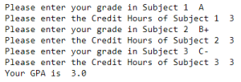

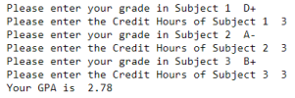Good Luck!